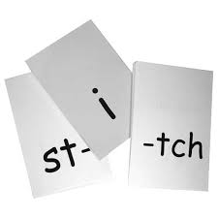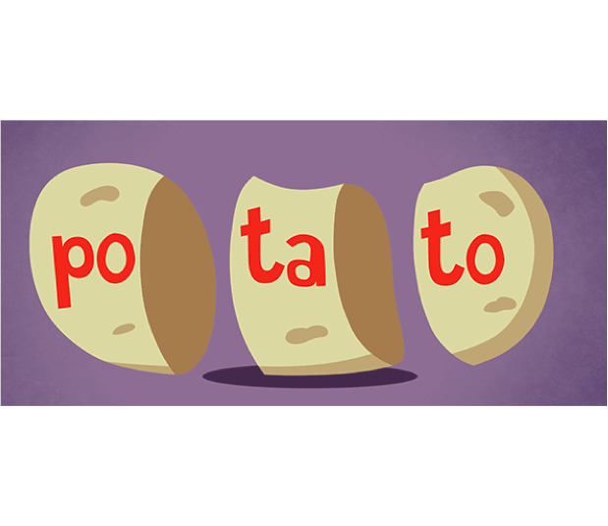 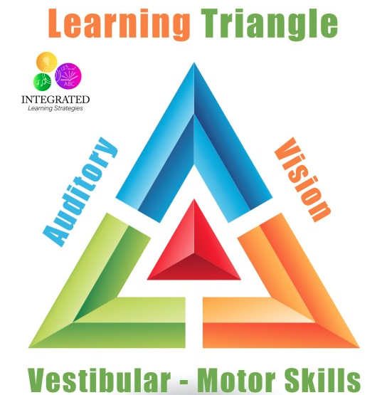

Reading comprehension

Reading rate or fluency

**Word reading accuracy**

**Who is it for?** Students who are struggling to learn to read.

**What is it?** The Orton-Gillingham Approach teaches the connections between sounds and letters.

It is a multisensory approach incorporates visual, auditory and kinesthetic methods to connect language with letters and words.

Instruction is done in small groups.

It is a highly structured program that teaches skills in a specific order.

#### The Orton-Gillingham Approach

**DSM-5: symptoms that have persisted for at least 6 months, despite interventions:**

* Slow and effortful word reading
* Reads words aloud incorrectly or slowly and hesitantly
* Frequently guess words
* Has difficulty sounding out words

The learning difficulties are not better accounted for by intellectual disabilities, other mental or neurological disorders, lack of proficiency in the language of academic instruction, or inadequate educational instruction.

**Phonological Awareness**

The theory with the most evidence suggests that decoding and word reading difficulties are caused by a deficit in phonological processing and therefore interventions are based on phonological awareness skills.

Phonological awareness skills:

1. Rhyming
2. Syllable division
3. Sound Discrimination
4. Phoneme Isolation
5. Sound Manipulation 

With impairment in reading

With impairment in word reading accuracy

Specific Learning Disorder

EDPS 658

Lianne Vroom

## Evidence-Based Interventions

* The Herman Approach (Herman, 1993)
* The Slingerland Approach (Slingerland & Aho, 1996)
* The Spalding Method (Spalding & Spalding, 1990)
* Starting Over (Knight, 1995)
* Project Read (Enfield & Greene, 1997)
* Alphabetic Phonics (Cox, 1992)
  + The Dyslexia Training Program (DTP)
* The Wilson Approach (Wilson, 1996)
* Project ASSIST (Biasotto, 1993)
* Explode the Code

Studies that cited positive outcomes for OG and OG-based instruction reported positive results for word reading, word attack/decoding and comprehension.

Positive effects were reported for first-grade children in general education classrooms, for elementary children at risk for or identified with reading disabilities and served in public schools, and elementary-age children in clinical settings.

(Ritchey & Goeke, 2006)

* 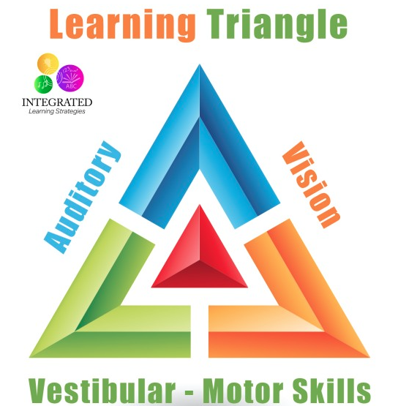

Duff, Fiona J. & Clarke, Paula J. (2011). Practitioner Review: Reading Disorders: What are the effective interventions and how should they be implemented and evaluated*? Journal of Child Psychology and Psychiatry,* 52(1), 3-12.

Giess, S. (2005). Effectiveness of a multisensory, orton-gillingham-influenced approach to reading intervention for high school students with reading disability. *ProQuest Dissertations & Theses Global*. Retrieved from <http://ezproxy.lib.ucalgary.ca/login?url=http://search.proquest.com/docview/304995671?accountid=9838>

Gillinghamn,A., & Stillman, W. (1997) The Gillingham manual. Remedial Training for students with specific disability in reading, spelling, penmanship. Cambridge,MA:Educators Publishing Service,Inc.

Holm,Farrier, & Dodd, B. (2008) Phonological awareness, reading accuracy and spelling ability of children with inconsistent phonological disorder. *International Journal Of Language & Communication Disorders* 43, 300-322. Doi: 10.1080/13682820701445032

Lim, L., & Oei, A. (2015) Reading and spelling gains following one year of Orton-Gillingham intervention in Singaporean students with dyslexia. *British Journal of Special Education*. 42, 374–389. DOI: 10.1111/1467-8578.12104

Ritchey, K. & Goeke, L. (2006). Orton-Gillingham and Orton-Gillingham-Based Reading Instruction: A Review of the Literature. *Journal Of Special Education*, *40*(3), 171-183.

Schuele, M. & Boudreau, D. (2008). Phonological awareness intervention: beyond the basics. *Language, Speech, & Hearing Services in Schools*, *39*.

Snowling, J., & Hulme, C. (2012). Annual Research Review: The nature and classification of reading disorders – a commentary on proposals for DSM-5. *Journal of Child Psychology and Psychiatry, and Allied Disciplines*, *53*(5), 593–607. DOI: 10.1111/j.1469-7610.2011.02495.x

Torgesen,J. (2000). Individual differences in response to early interventions in reading: The lingering problem of treatment resisters. *Learning Disabilities Research and Practice*, *15,* 55-64.

Torgesen, J.,Wagner, R., & Rashotte, C. (1994). Longitudinal studies of phonological processing and reading. *Journal of Learning Disabilities, 27,* 276-286.

Turner, M. (2008). This systematic review empirically documents that the effectiveness of Orton-Gillingham and Orton-Gillingham-based reading instruction remains to be determined. *Evidence-Based Communication Assessment & Intervention*, *2*(2), 67-69. doi:10.1080/17489530802037564

## References: